- European Company AAA buys Crude Oil. Hedge Price Risk & Currency Risk.
Schedule of shipments:
 | 1M | 2M | 3M
Shipment of Crude Oil | 1,000,000 Barrels | 1,000,000 Barrels | 1,000,000 Barrels

As a buyer we want to spend less money on purchasing oil. Final price equation:
$Price =\frac{PriceUSD}{EUR/USD}$
Best case $PriceUSD$ - ↓; EUR/USD - ↑. (Oil price decline + Weak dollar against the euro)
$Price =\frac{PriceUSD - ProfitOIL}{EUR/USD + ProfitCUR}$

FU($PriceUSD$) + FU(EUR/USD):
M1: $Price =\frac{72.990 }{1.1815} =61.77$
M2: $Price =\frac{72.920 }{1.1823 } =61.67$
M3: $Price =\frac{72.260 }{ 1.1829} =61.08$
For crude oil price Barrel/USD:
- Speculation with CO (to buy) + PO (to buy) + FU (to sell)

Product / Term | Spot | FU 1M | FU 2M | FU 3M
Crude Oil | 72.920 | 72.990 | 72.920 | 72.260
Gasoline | 2.150 | 2.282 | 2.154 | 2.093

Crude Oil
Put Option |  |  | Strike | Call Option
3M | 2M | 1M |  | 1M | 2M | 3M
1.60 | 1.20 | 0.50 | 65.000 | 10.50 | 11.80 | 13.50
2.40 | 2.10 | 1.30 | 67.000 | 8.40 | 9.60 | 11.30
3.90 | 3.30 | 2.60 | 69.000 | 5.20 | 7.60 | 7.80
8.20 | 7.20 | 5.30 | 71.000 | 3.30 | 3.70 | 4.70
11.40 | 9.60 | 8.70 | 73.000 | 2.10 | 2.20 | 2.60
13.30 | 12.10 | 10.40 | 75.000 | 0.60 | 0.90 | 1.70
M1
CO (to buy) Right / No obl. to buy | Strike II (73) | Cost I (2.1)
PO (to buy) No Right / Obl. to buy | Strike II (73) | Cost II (8.7)
FU (to sell) Right / Obl. to sell | Strike I (72.990)

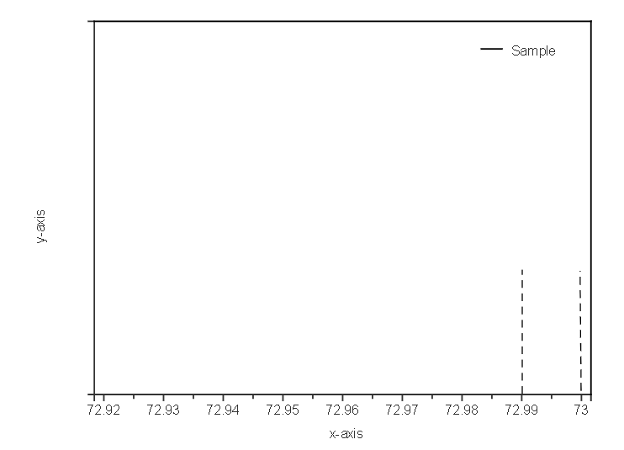

1 MONTH:
- Spot (72.920) < Strike I (72.990):
  - 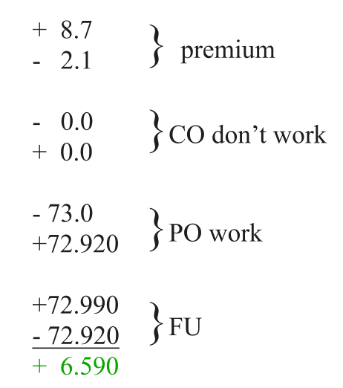
Cost II - Cost I + Strike I(FU) - Strike II = +6.590$

- Strike I (72.990) < Spot (72.995) < Strike II (73):
  - 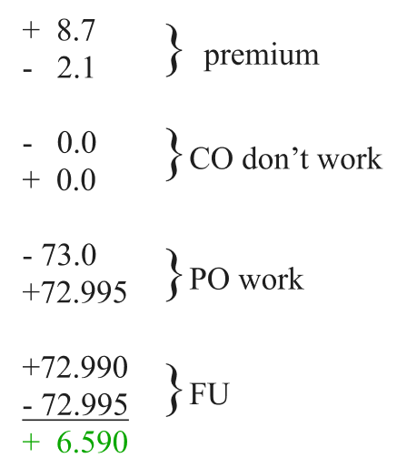
Cost II - Cost I + Strike I(FU) - Strike II = +6.59$

- Strike II (73) < Spot (75):
  - 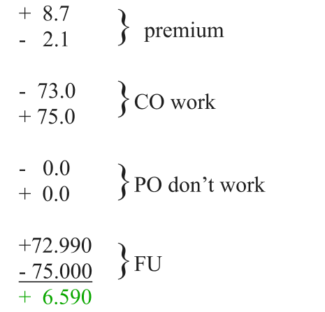
Cost II - Cost I + Strike I(FU) - Strike II = +6.59$
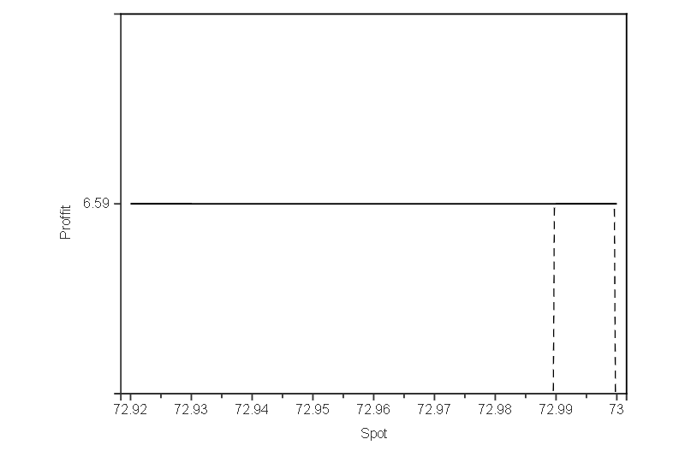 Figure1 - M1 Contract
M1
Cost II - Cost I + Strike I(FU) - Strike II = 9.6 - 2.2 + 72.920 - 73.0 = +6.590$

M2
Cost II - Cost I + Strike I(FU) - Strike II = 9.6 - 2.2 + 72.920 - 73.0 = +7.320$

M3
Cost II - Cost I + Strike I(FU) - Strike II = 11.40 - 2.60 + 72.260 - 73.0 = +8.060$

Price we spend to M1 contract USD/bar: Spot - profit = Spot - 6.590$
Price we spend to M2 contract USD/bar: Spot - profit = Spot - 7.320$
Price we spend to M3 contract USD/bar: Spot - profit = Spot - 8.060$

Advantages:
- No risk involved.
- Guaranteed (fixed) profit.
- Better results compared to a simple Future(to buy) + Future(to sell) strategy.

Disadvantages:
- Profit does not increase even if market volatility is high.

To prevent volatility of currency EUR/USD:
- Speculation with COI (to sell) + COII (to buy)

Currency | Spot | FU 1M | FU 2M | FU 3M
EUR/USD | 1.1808 | 1.1815 | 1.1823 | 1.1829

Put Option |  |  | Strike | Call Option
3M | 2M | 1M |  | 1M | 2M | 3M
0.0060 | 0.0043 | 0.0033 | 1.1750 | 0.0117 | 0.0184 | 0.0207
0.0077 | 0.0059 | 0.0041 | 1.1775 | 0.0100 | 0.0150 | 0.0174
0.0097 | 0.0078 | 0.0051 | 1.1800 | 0.0085 | 0.0119 | 0.0144
0.0120 | 0.0102 | 0.0062 | 1.1825 | 0.0071 | 0.0093 | 0.011
0.0147 | 0.0130 | 0.0075 | 1.1850 | 0.0059 | 0.0071 | 0.0094
0.0178 | 0.0162 | 0.0089 | 1.1875 | 0.0048 | 0.0053 | 0.0075
0.0211 | 0.0198 | 0.0105 | 1.1900 | 0.0039 | 0.0039 | 0.0059

M1
COI (to sell) No Right / Obl. to sell Strike I(1.1750) | Cost I (0.0117)
COII (to buy) Right / No Obl. to buy Strike II(1.1825) | Cost II (0.0071)
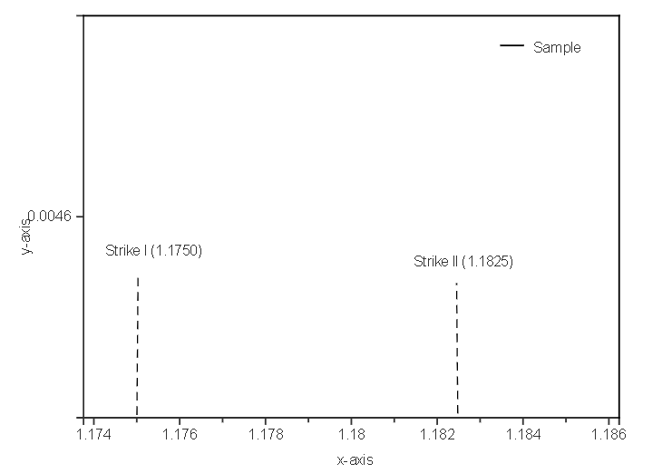

1 MONTH:
- Spot (1.1740) < Strike I (1.1750):
  - 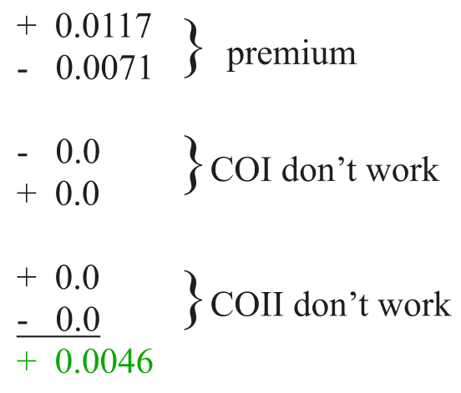
  - Profit = Cost I - Cost II = +0.0046

- Strike I (1.1750) < Spot (1.1808) < Strike II (1.1825):
  - 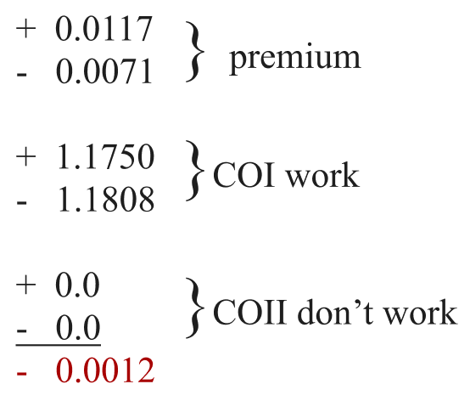
  - Profit = Cost I - Cost II + Strike I - Spot
    - if Spot = Strike I + Cost I - Cost II -> Profit 0
    - If Spot > 1.1796 -> lose on currency

- Strike II (1.1825) < Spot (1.1840):
  - 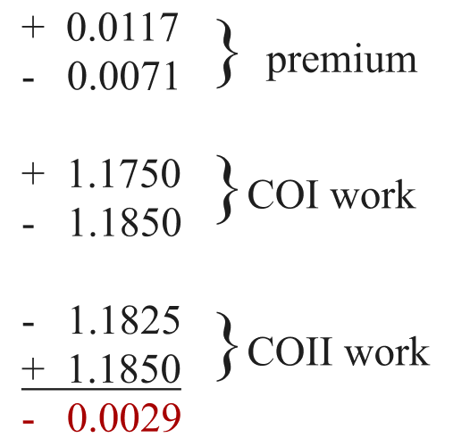
  - Profit = Cost I - Cost II + Strike I - Strike II = -0.0029
    - If Spot > 1.1825 -> max lose on currency

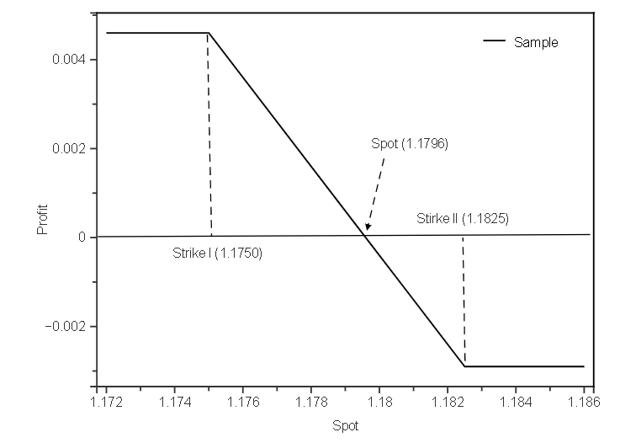
Figure 2 - 1M contract

2 MONTHS: (Arbitrage situation)
- Spot (1.1740) < Strike I (1.1750):
  - Profit = Cost I - Cost II = 0.0184 - 0.0093 =+ 0.0091
    - Max profit situation

- Strike I (1.1750) < Spot (1.1808) < Strike II (1.1825):
  - Profit = Cost I - Cost II + Strike I - Spot = + 0.0033

- Strike II (1.1825) < Spot (1.1840):
  - Profit = Cost I - Cost II + Strike I - Strike II = + 0.0016
    - Min profit situation

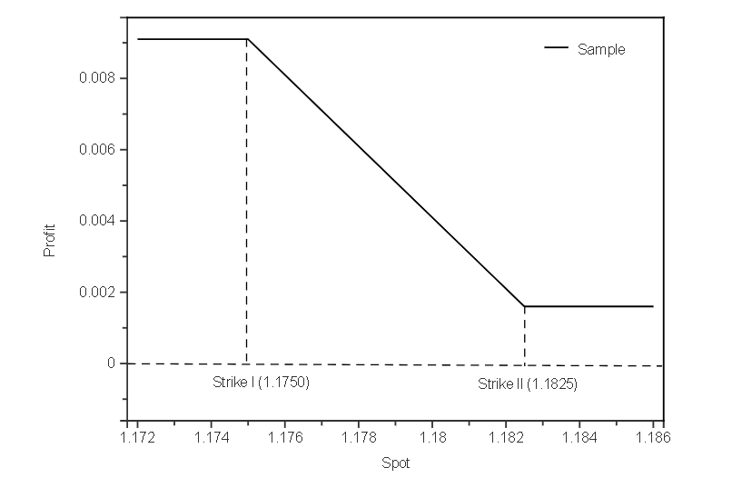
Figure 3 - 2M contract

3 MONTHS: (Arbitrage situation)
- Spot (1.1740) < Strike I (1.1750):
  - Profit = Cost I - Cost II = 0.0207 - 0.011 =+ 0.0093
    - Max profit situation

- Strike I (1.1750) < Spot (1.1808) < Strike II (1.1825):
  - Profit = Cost I - Cost II + Strike I - Spot = + 0.0039

- Strike II (1.1825) < Spot (1.1840):
  - Profit = Cost I - Cost II + Strike I - Strike II = + 0.0022
    - Min profit situation
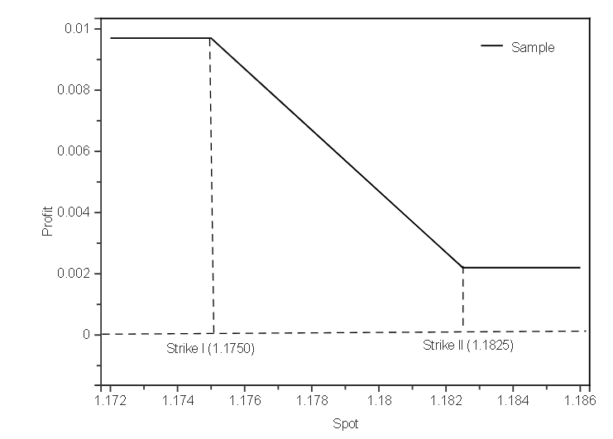
Figure 4 - 3M contract
- Spot < Strike I (1.1750) :
  - Price to M1 contract EUR/USD: Spot + profit = Spot + 0.0046
  - Price to M2 contract EUR/USD: Spot + profit = Spot + 0.0091
  - Price to M3 contract EUR/USD: Spot + profit = Spot + 0.0093

- Strike I (1.1750) < Spot (1.1808) < Strike II (1.1825) :
  - Price to M1 contract EUR/USD: Spot + profit = Spot - 0.0012
  - Price to M2 contract EUR/USD: Spot + profit = Spot + 0.0033
  - Price to M3 contract EUR/USD: Spot + profit = Spot + 0.0039

- Strike II (1.1825) < Spot :
  - Price to M1 contract EUR/USD: Spot + profit = Spot - 0.0029
  - Price to M2 contract EUR/USD: Spot + profit = Spot + 0.0016
  - Price to M3 contract EUR/USD: Spot + profit = Spot + 0.0022

P_{final}$=\frac{SPOToil - PROFIToil}{SPOTcurrency + PROFITcurrency⁦}$

Product / Term | Spot | FU 1M | FU 2M | FU 3M
Crude Oil | 72.920 | 72.990 | 72.920 | 72.260

Currency | Spot | FU 1M | FU 2M | FU 3M
EUR/USD | 1.1808 | 1.1815 | 1.1823 | 1.1829

M1 | M2 | M3
Spot_{oil} = 72.920 ; Spot_{currency} = 1.1808
56.23 EUR/bar | 55,40 EUR/bar | 54,74 EUR/bar

WORST CASE(The highest price we will pay when … ):
- Spot_{currency} < Strike I (1.1750)
- Spot_{oil} > Strike II (73.00)

M1 | M2 | M3
Spot_{oil} = 75 ; Spot_{currency} = 1.1740
58,04 EUR/bar | 57,20 EUR/bar | 56,57 EUR/bar

BEST CASE(The Lowest price we will pay when …):
- Spot_{currency} > Strike II (1.1825)
- Spot_{oil} < Strike I (72.990)

M1 | M2 | M3
Spot_{oil} = 72 ; Spot_{currency} = 1.1830
55.42 EUR/bar | 54.60 EUR/bar | 53.94 EUR/bar

FU($PriceUSD$) + FU(EUR/USD):
M1 | M2 | M3
$61.77$ EUR/bar | $61.67$ EUR/bar | $61.08$ EUR/bar

M1 | M2 | M3
Spot_{oil} = 72 ; Spot_{currency} = 1.1740
55,4 EUR/bar | 54.66 EUR/bar | 54.03 EUR/bar
Spot_{oil} = 72 ; Spot_{currency} = 1.1808
55.45 EUR/bar | 54.62 EUR/bar | 53.97 EUR/bar
Spot_{oil} = 72 ; Spot_{currency} = 1.1830
55.42 EUR/bar | 54.60 EUR/bar | 53.94 EUR/bar

M1 | M2 | M3
Spot_{oil} = 73 ; Spot_{currency} = 1.1740
56,34 EUR/bar | 55,51 EUR/bar | 54,88 EUR/bar
Spot_{oil} = 73 ; Spot_{currency} = 1.1808
56,29 EUR/bar | 55,46 EUR/bar | 54,81 EUR/bar
Spot_{oil} = 73 ; Spot_{currency} = 1.1830
56,27 EUR/bar | 55,44 EUR/bar | 54,7 EUR/bar

M1 | M2 | M3
Spot_{oil} = 75 ; Spot_{currency} = 1.1740
58,04 EUR/bar | 57,20 EUR/bar | 56,57 EUR/bar
Spot_{oil} = 75 ; Spot_{currency} = 1.1808
57,99 EUR/bar | 57,15 EUR/bar | 56,50 EUR/bar
Spot_{oil} = 75 ; Spot_{currency} = 1.1830
57,96 EUR/bar | 57,13 EUR/bar | 56,47 EUR/bar

